Git Pull Request (PR)

Objective
To implement a feature using a separate branch and merge it into the main branch using a Pull Request.

Create Feature Branch
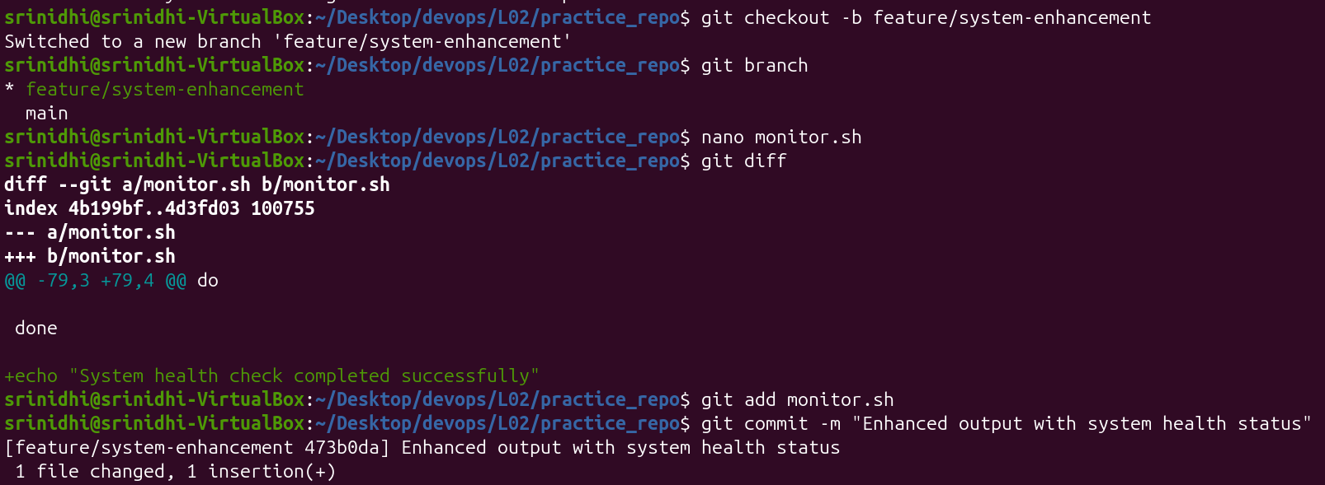

Command
git checkout -b feature/system-enhancement

Purpose
Creates a new branch and switches to it.

Add Feature Changes
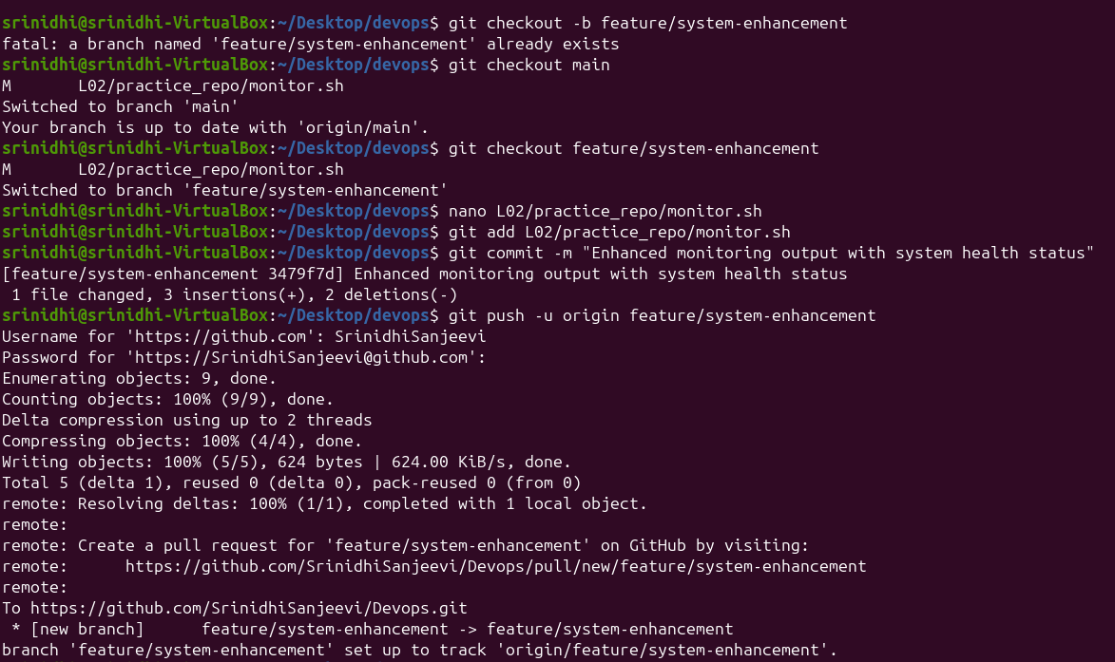

Commands
nano monitor.sh
git add monitor.sh
git commit -m "Enhanced output with system health status"

Purpose
Feature enhancement was implemented in an isolated branch.

Push Branch
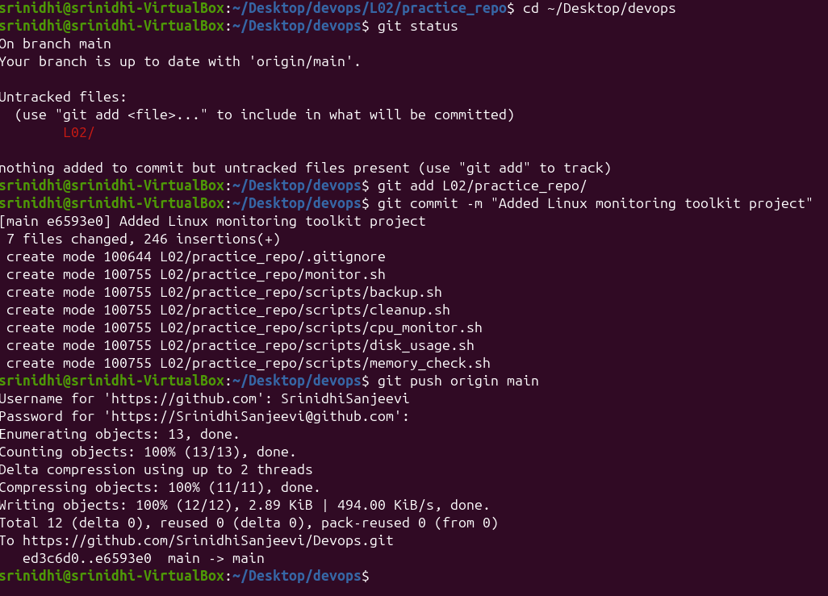

Command
git push -u origin feature/system-enhancement

Purpose
Uploads branch changes to GitHub.

Create Pull Request
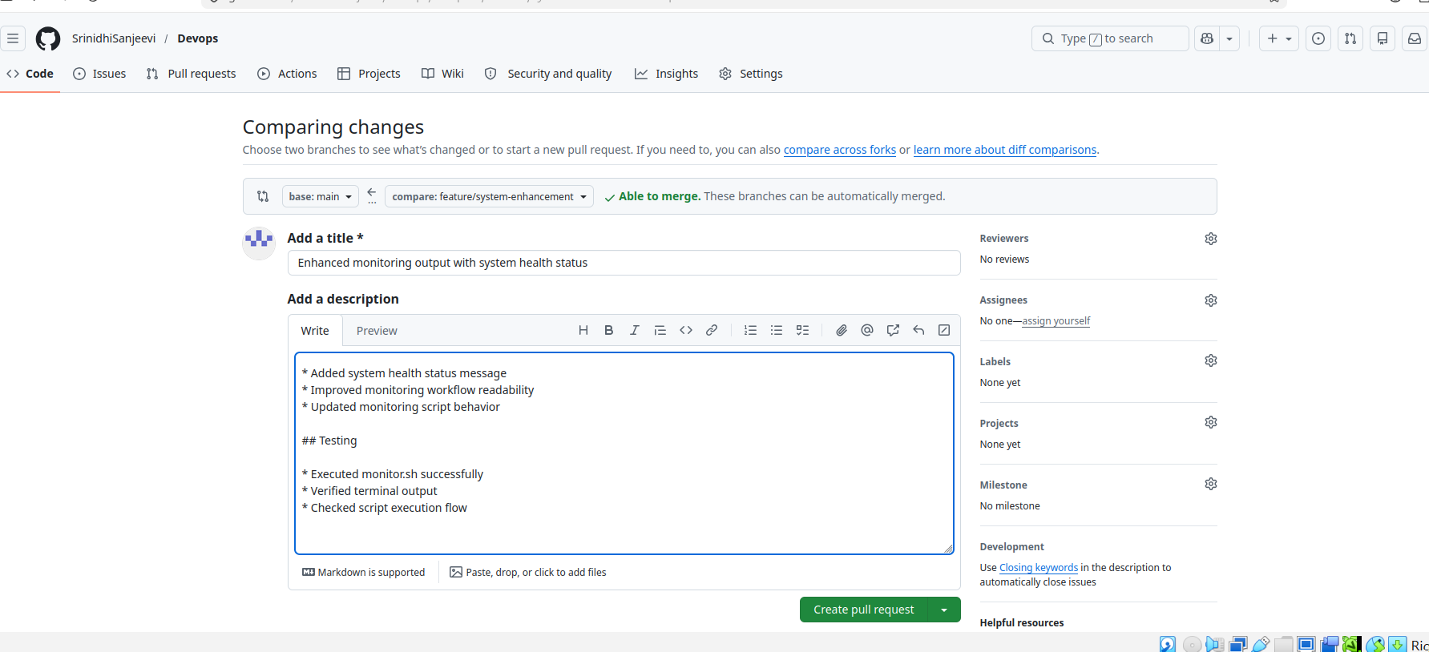

Purpose
A Pull Request was created to:
- Review changes
- Discuss improvements
- Merge feature safely

Code Review
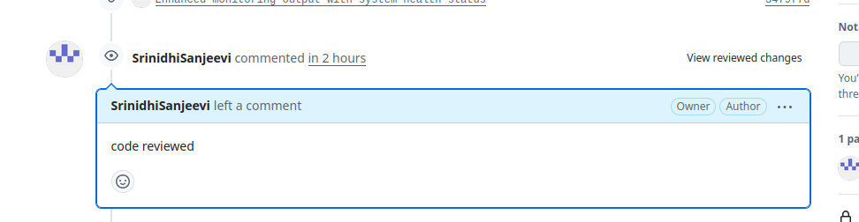

Purpose
Code review helps:
- Improve code quality
- Detect issues early
- Maintain standards

Merge Pull Request
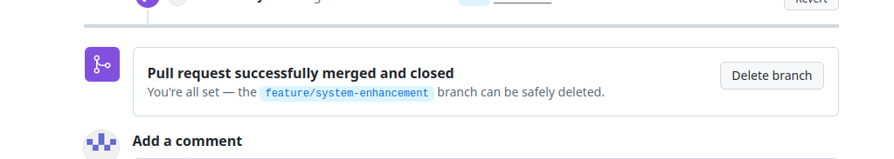

Purpose
After review approval, the Pull Request was merged into the main branch.

Outcome
Successfully implemented a feature using Git branching and Pull Request workflow and merged the changes into the main branch.

